 | Testing and Training Center of Farm Machinery  Department of Farm Machinery and Power  College of Agricultural Engineering and Technology  Junagadh Agricultural University  JUNAGADH – 362 001 (GUJARAT) | 
P | Phone : (0285) 2672080-90, Ext. 390 & 484; Fax : (0285) 2671018

SPECIFICATION SHEET OF TRACTOR DRAWN BUND FORMER

1.0 | General | :
1.0 | Name of machine | :
1.0 | Name and address of manufacturer | :
1.0 | Name and address of applicant | :
1.0 | Selling price in India | :

2.1 | Main frame:
2.1 | a) | Type and material |  | :
2.1 | b) | Size (mm) |  | :
 | c) | Ground clearance (mm) |  | :
2.2 | Cutting blade
 | a) | Type and material | :
 | b) | Number | :
 | c) | Size (mm) | :
 | d) | Thickness (mm) | :
 | e) | Distance from centre to centre of blades (mm) | :
2.3 | Forming boards :
 | a) | Material | :
 | b) | Shape of board | :
 | c) | Number of boards | :
 | d) | Distance between forming boards (mm)
 |  | Front side | :
 |  | Rear side | :
 | e) | Top opening of forming boards (mm)
 |  | Front side | :
 |  | Rear side | :
 | f) | Max. width between forming boards at rear (mm) | :
 |  |  |  |  | LHS | RHS
 | g) | Length (mm) | :
 | h) | Width (mm) | :
 | i) | Thickness (mm) | :
 | j) | Total no. of holes | :
 | k) | Dia. of hole (mm) | :
 | l) | Hole to hole distance (mm)
 |  | Horizontal | :
 |  | Vertical | :
 | m) | Width of cutting edge (mm) | :
 | n) | Length of cutting edge (mm) | :
 | o) | Method of fixing | :
2.4 | Forming board braces
 | a) | Type and material | :
 | b) | No. of support | :
 | c) | Method of fixing | :
2.5 | Type of hitch and its details :
 | a) | Type and material | :
 | b) | Shape | :

Specification of Hitch Pyramid As per IS: 4468-1997 (Part-I)

Sr. | Dimension  (Refer Fig.1) | Description | Measurement
Upper Hitch attachments
1 | d₁ | Diameter of hitch pin hole
2 | b’₁ | Width between inner faces of yoke
3 | b’₂ | Width between outer faces of yoke
Lower hitch points
4 | D₂ | Dia. of hitch pin
5 | b’₃ | Linch pin hole distance
6 | l | Lower hitch point span
Other dimensions
 | Diameter of linch pin hole
7 | d | For upper hitch pin
8 |  | For lower hitch pin
9 | h | Mast height

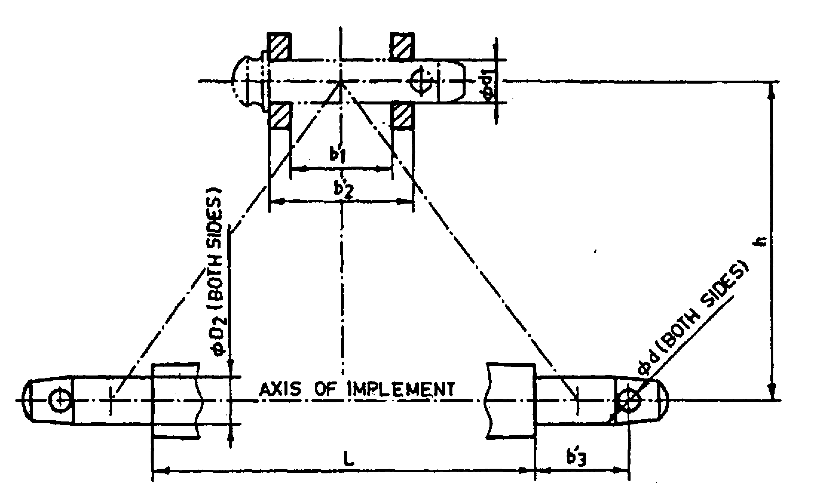
Implement Hitch Attachment

3 | Overall Dimensions (mm)
3 | a) | Length | :
3 | b) | Width | :
3 | c) | Height | :
3 | d) | Mass, (kg) | :

4 | Color of implement | :
5 | Details of Material of Construction :
Sr. | Name of components | Material
1 | Frame
2 | Hitch assembly
3 | Forming boards
4 | Adjustment level
5 | Cutting blade
6 | Hitch pin

Place:
Date:
Signature : _________________________

Name : _________________________

Designation: ________________________

