 | Testing and Training Center of Farm Machinery  Department of Farm Machinery and Power  College of Agricultural Engineering and Technology  Junagadh Agricultural University  JUNAGADH – 362 001 (GUJARAT) | 
P | Phone : (0285) 2672080-90, Ext. 390 & 484; Fax : (0285) 2671018

SPECIFICATION SHEET OF CULTIVATOR (TRACTOR DRAWN)

1.0 |  | General |  | :
 |  | Name of machine |  | :
 |  | Name and address of manufacturer |  | :
 |  | Name and address of applicant |  | :
 |  | Selling price in India |  | :
2.1 | Constructional details:
2.1 | a) |  | Name | :
2.1 | b) |  | Type | :
2.1 | c) |  | Make | :
2.1 | d) |  | Serial Number | :
2.1 | e) |  | Model | :
2.1 | f) |  | Year of manufacture | :
2.1 | g) |  | No. of tines | :
2.1 | h) |  | Size of cultivator (mm) | :
2.1 | i) |  | Source of power | :
2.2 |  | Frame:
 |  | a) | Constructional details | :
 |  | b) | Dimensions (mm) | :
2.3 |  | Tyne:
 |  | a) | No of tynes | :
 |  | b) | Arrangement on main frame | :
 |  | c) | Type | :
 |  | d) | Material | :
 |  | e) | Size (mm) | :
 |  | f) | Length (mm)
 |  |  | - curved | :
 |  |  | - projected | :
 |  | g) | Width (mm)
 |  |  | - at top | :
 |  |  | - at bottom | :
 |  | h) | No. and size of hole on each tyne for fixing shovel to it | :
 |  | i) | Center to center distance between the holes (mm) | :
 |  | j) | No. and size of bolts for tightening shovel to the tyne | :
 |  | k) | Method of fixing | :
 |  | l) | Provision for height adjustments | :
2.4 |  | Shovel :
 |  | a) | No. of shovel | :
 |  | b) | Type | :
 |  | c) | Material | :
 |  | d) | No. and size of holes on each shovel for fixing to tyne | :
 |  | e) | Method of fixing | :
2.5 |  | Hitch Pyramid:
 |  | a) | Constructional details | :
 |  | b) | Material | :
 |  | c) | Size (mm) | :

Sr. | Dimension | Description (Refer Fig.) | Dimension in mm
Upper Hitch attachments
1 | d₁ | Diameter of hitch pin hole
2 | b’₁ | Width between inner faces of yoke
3 | b’₂ | Width between outer faces of yoke
Lower hitch points
4 | D₂ | Dia of hitch pin
5 | b’₃ | Linch pin hole distance
6 | l | Lower hitch point span
Other dimensions
 | Diameter of linch pin hole
7 | d | For upper hitch pin
8 |  | For lower hitch pin
9 | h | Mast height
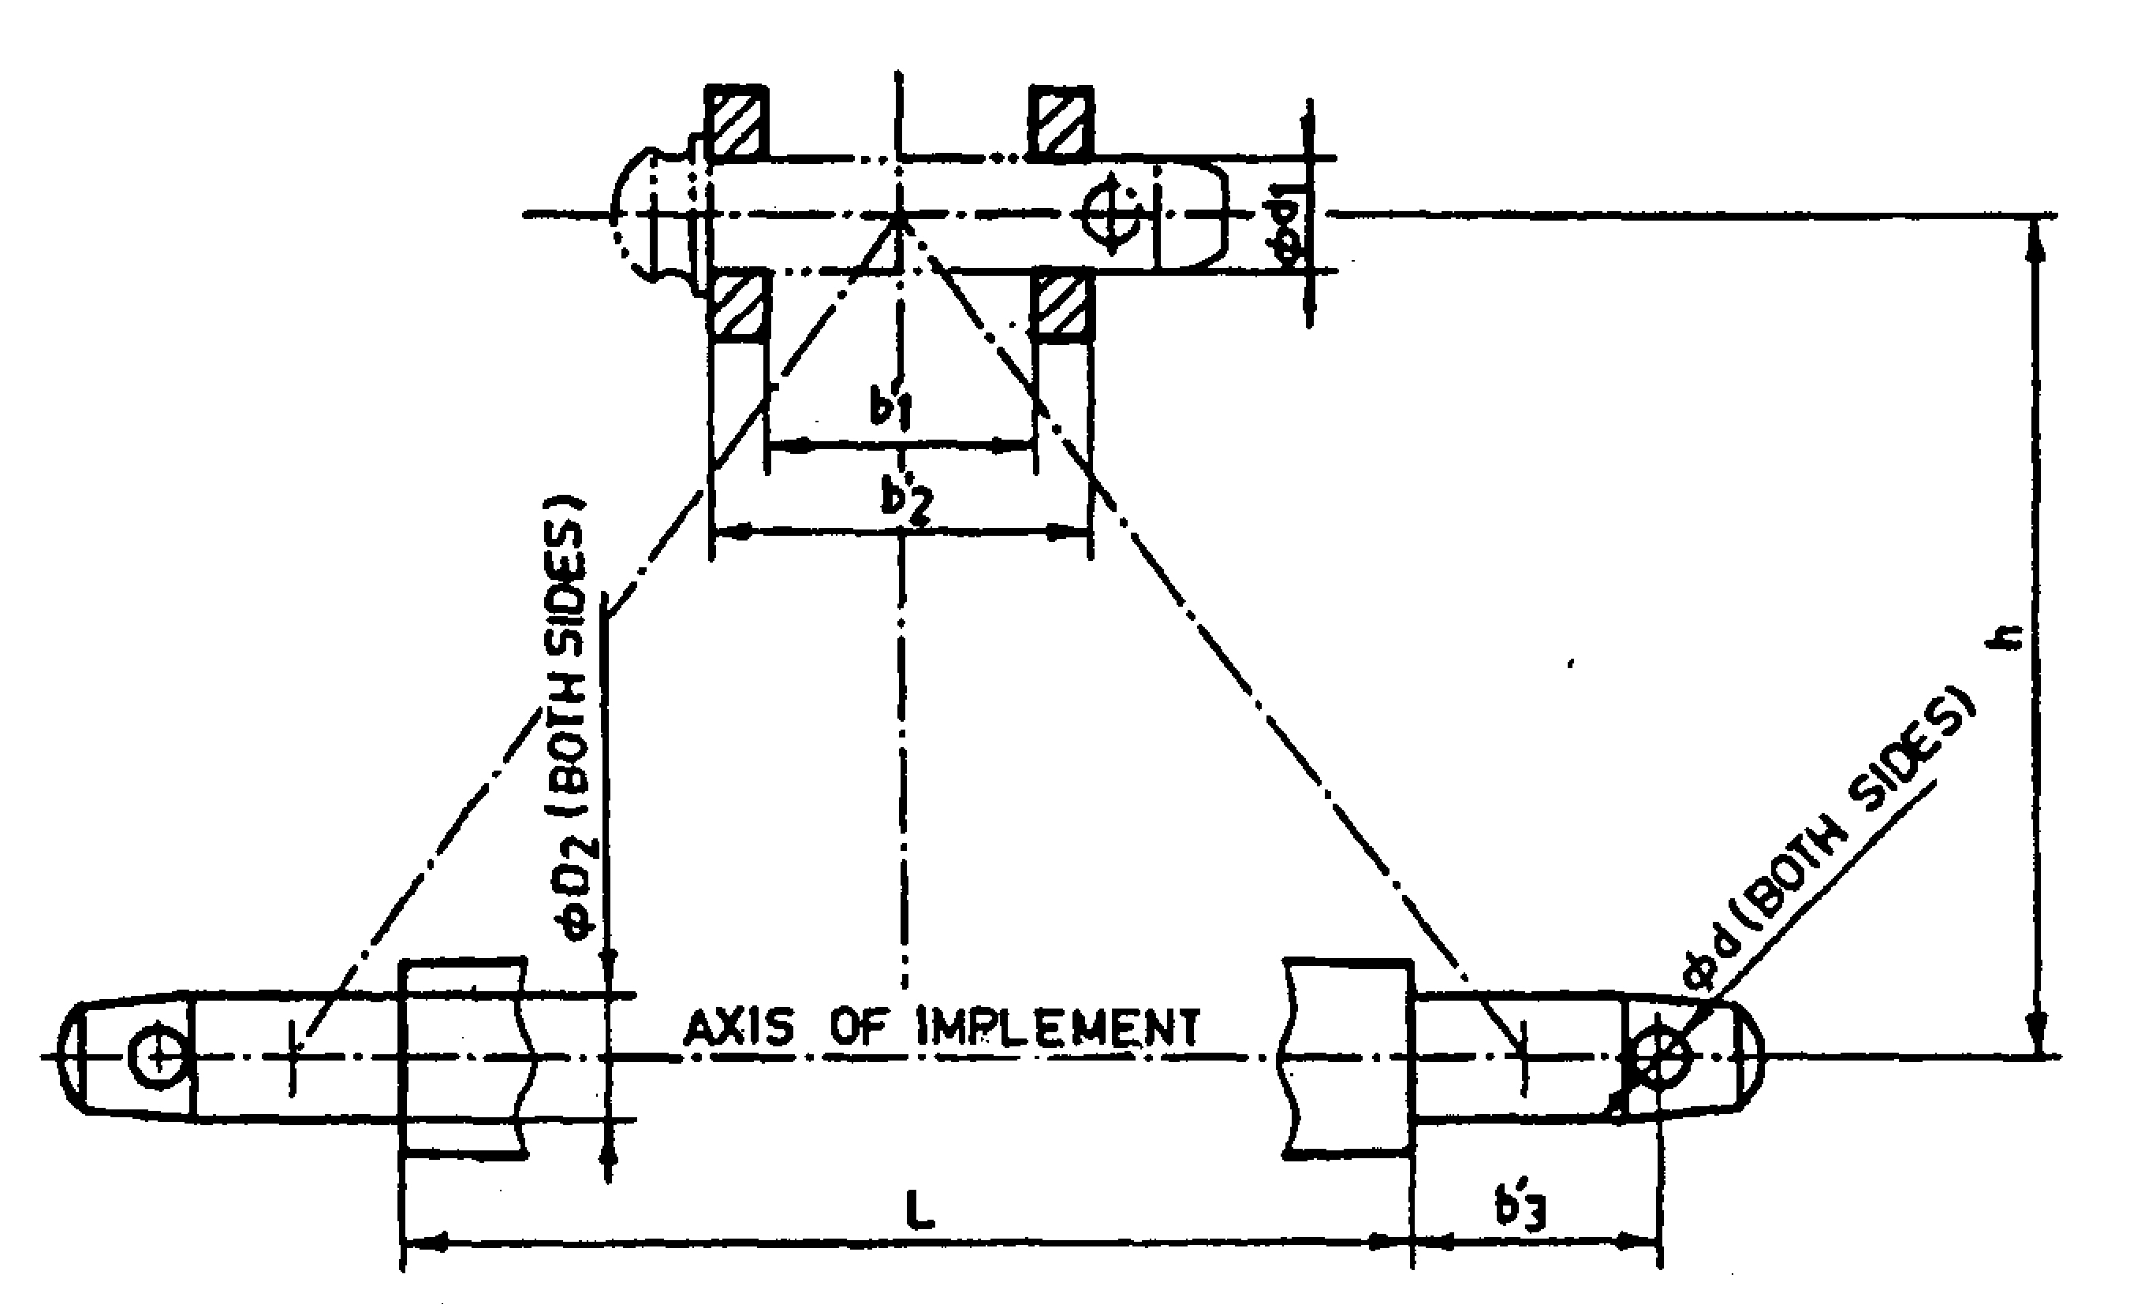
Fig. : Implement Hitch Attachment

4.3 | Material of construction:
4.3 | Name of components |  | Material used | Size (mm)
4.3 | a) | Main frame
4.3 | b) | Tyne
4.3 | c) | Shovel
4.3 | d) | Hitch pyramid

4.4 | Overall dimensions (mm):
4.4 | a) | Length | :
4.4 | b) | Width | :
4.4 | c) | Height | :
4.5 | Total mass (kg) |  | :
4.6 | Color of implement |  | :

Place:
Date:
Signature : ________________________

Name : ________________________

Designation: ________________________

