 | Testing and Training Center of Farm Machinery  Department of Farm Machinery and Power  College of Agricultural Engineering and Technology  Junagadh Agricultural University  JUNAGADH – 362 001 (GUJARAT) | 
P | Phone : (0285) 2672080-90, Ext. 390 & 484; Fax : (0285) 2671018

SPECIFICATION SHEET OF TRACTOR MOUNTED LEVELLER

1.0 | General | :
1.0 | Name of machine | :
1.0 | Name and address of manufacturer | :
1.0 | Name and address of applicant | :
1.0 | Selling price in India | :

2.1 | Main frame:
2.1 | a) |  | Constructional details |  | :
2.1 | b) |  | No. and size of bolts (mm) for tightening square section to the Mould board frame |  | :
2.2 | Mould board frame:
2.2 | a) |  | Constructional details |  | :
2.2 | b) |  | Shape |  | :
2.2 | c) |  | Size of material (mm) |  | :
2.2.1 | Mould board (tynes):
2.2.1 | a) |  | Constructional details |  | :
2.2.1 | b) |  | No. and size (mm) |  | :
2.2.2 | Side plate:
2.2.2 | a) |  | Constructional details |  | :
2.2.2 | b) |  | No. and size (mm) |  | :
2.3 | Mould board:
2.3 | a) |  | Constructional details |  | :
2.3 | b) |  | Size (mm) |  | :
2.3 | c) |  | Volume of mould board (cu. m.) |  | :
2.4 | Cutting blade
2.4 | a) |  | Material and size (mm) |  | :
2.4 | b) |  | Beveled edge thickness (mm) |  | :
2.4 | c) |  | Width of beveled edge (mm) |  | :
2.4 | d) |  | No. and size (mm) of holes on the blade |  | :
2.4 | e) |  | No., size and types of bolts for fitting blade (mm) |  | :
2.4 | f) |  | Method of fixing |  | :
2.5 | Blade tilt or vertical angle device:
2.5 | a) |  | Constructional details |  | :
2.5 | b) |  | No. and size (mm) of holes on mast rear flats |  | :
2.5 | c) |  | Hole spacing (mm) |  | :
2.5 | d) |  | Range of blade tilt angle from ground level (GL) (degree) |  | :
2.5 | e) |  | Size of U-channel (mm) |  | :
2.5 | f) |  | No. and size (mm) of holes on U-channel |  | :
 | g) |  | No. and size (mm) of bolt for tightening the mast flat |  | :
2.6 | Horizontal angling device |  |  |  | :
2.7 | Pitch adjusting screw |  |  |  | :
2.8 | Scarifier |  |  |  | :
2.9 | Stabilizer kit |  |  |  | :
2.10 |  | Type of hitch and its details :
 |  | a) |  | Type and material | : | Three point linkage, MS Flat, 62.5 x 12
 |  | b) |  | Shape | : | Pyramid

Specification of Hitch Pyramid As per IS: 4468-1997 (Part-I)

Sr. | Dimension  (Refer Fig.1) | Description | Measurement
Upper Hitch attachments
1 | d₁ | Diameter of hitch pin hole
2 | b’₁ | Width between inner faces of yoke
3 | b’₂ | Width between outer faces of yoke
Lower hitch points
4 | D₂ | Dia. of hitch pin
5 | b’₃ | Linch pin hole distance
6 | l | Lower hitch point span
Other dimensions
 | Diameter of linch pin hole
7 | d | For upper hitch pin
8 |  | For lower hitch pin
9 | h | Mast height

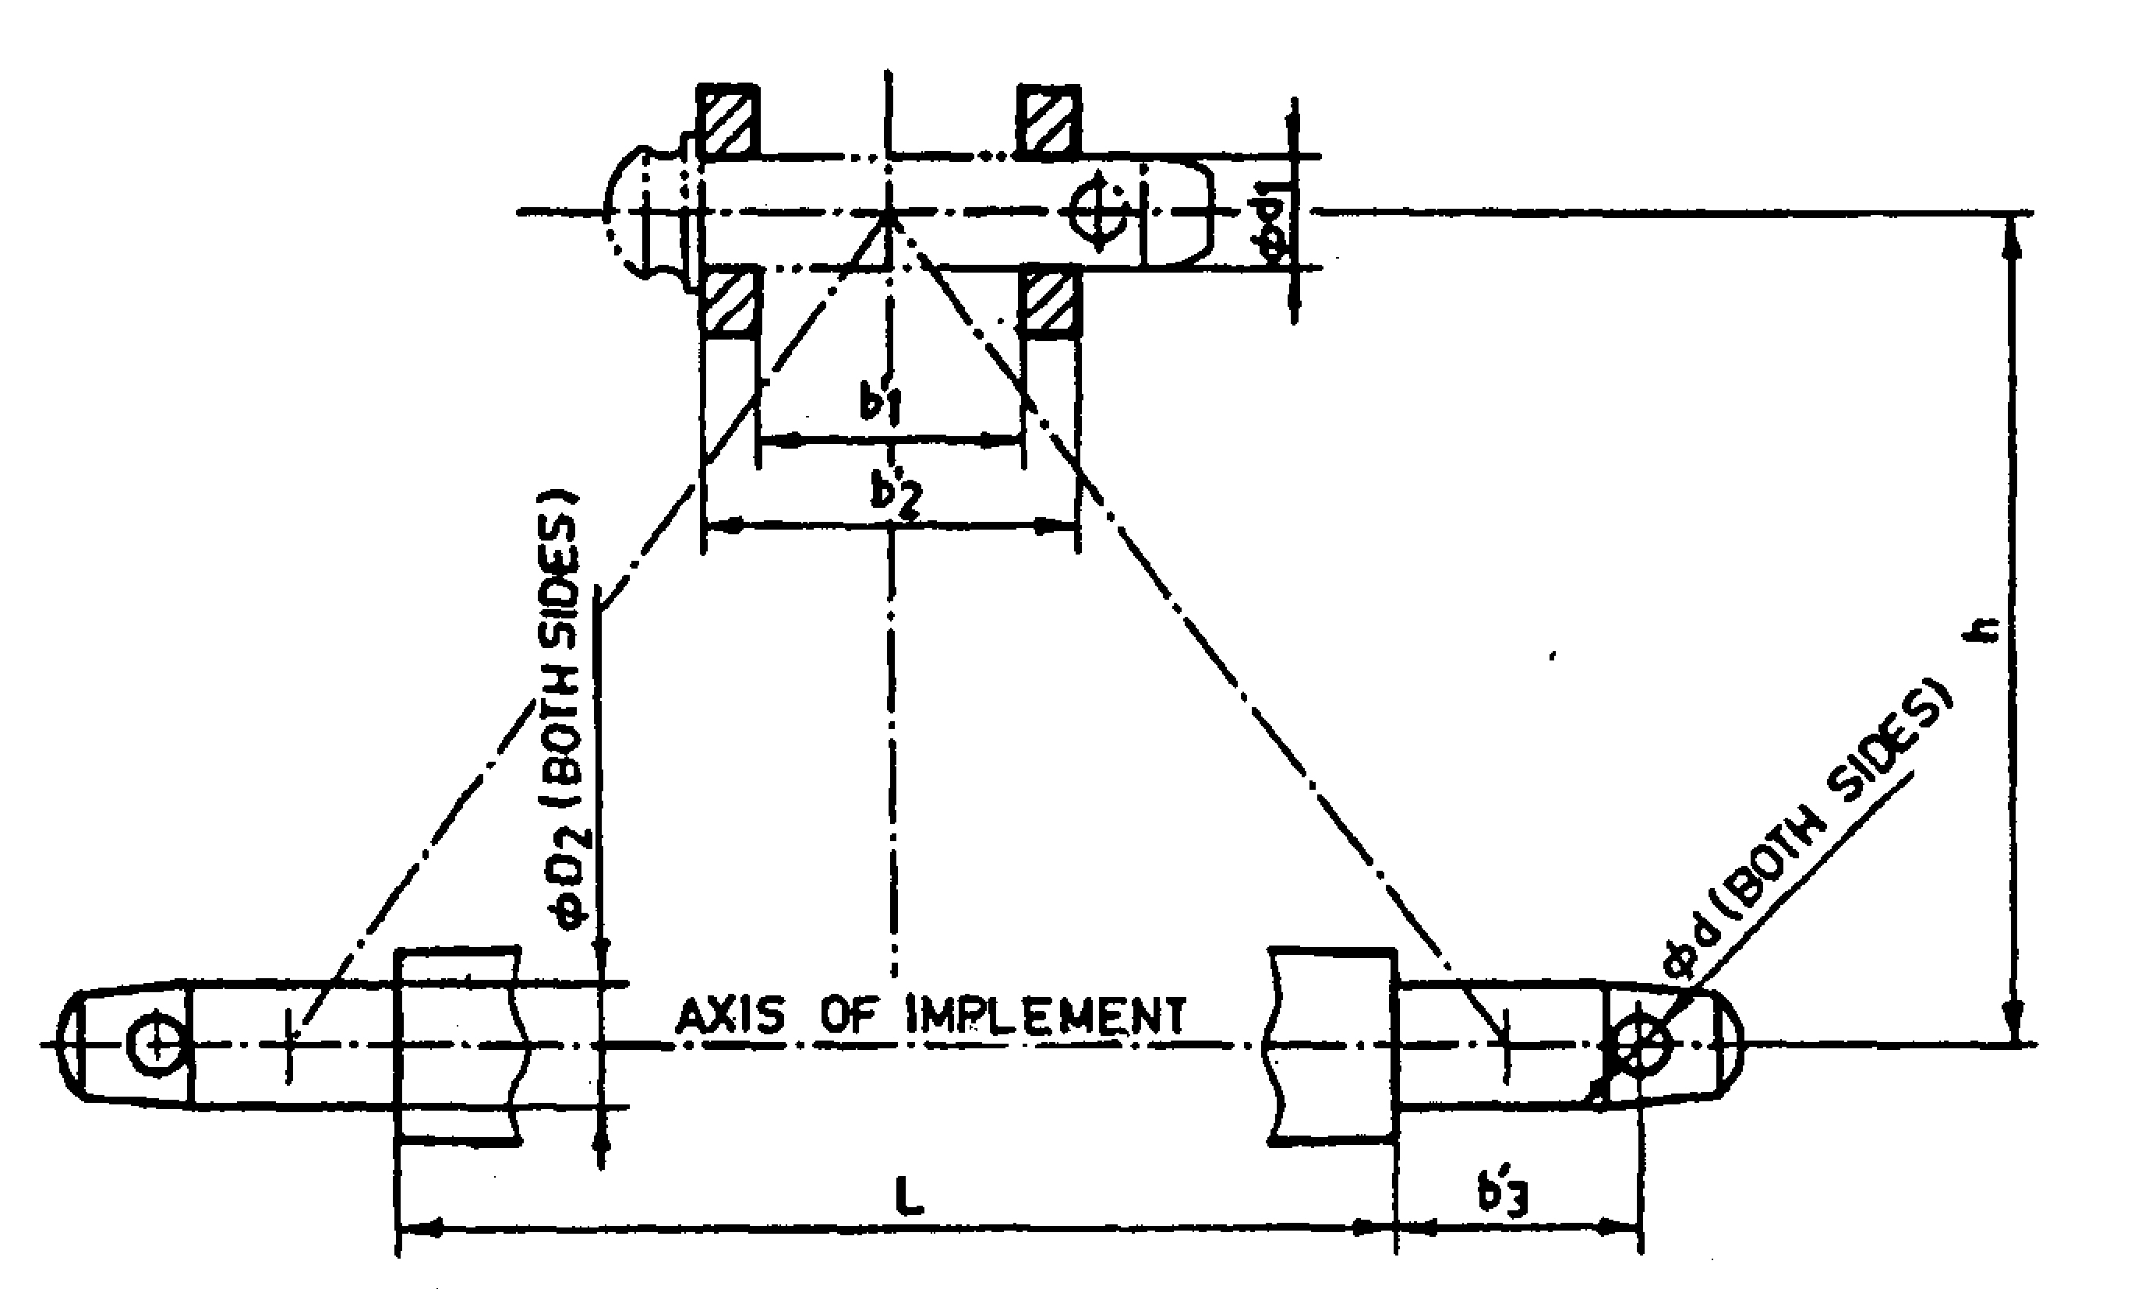
Implement Hitch Attachment

3 | Overall Dimensions (mm)
3 | a) | Length | :
3 | b) | Width | :
3 | c) | Height | :
3 | d) | Mass, (kg) | :

4 | Color of implement | :
5 | Details of Material of Construction :

Sr. | Name of components | Material
1 | Frame | Conforms
2 | Strut hitch | --
3 | Hitch pin | Does not conform
4 | Pitch adjusting screw | --
5 | Mould board frame | Conforms
6 | Side plate | Conforms
7 | Mould board | Conforms
8 | Scarifier | --

Place:
Date:
Signature : _________________________

Name : _________________________

Designation: ________________________

