 | Testing and Training Center of Farm Machinery  Department of Farm Machinery and Power  College of Agricultural Engineering and Technology  Junagadh Agricultural University  JUNAGADH – 362 001 (GUJARAT) | 
P | Phone : (0285) 2672080-90, Ext. 390 & 484; Fax : (0285) 2671018

SPECIFICATION SHEET OF TRACTOR MOUNTED MECH. REV. M.B. PLOUGH

1.0 |  | General |  |  |  |  |  |  |  |  |  |  |  |  |  |  | :
 |  | Name of machine |  |  |  |  |  |  |  |  |  |  |  |  |  |  | :
 |  | Name and address of manufacturer |  |  |  |  |  |  |  |  |  |  |  |  |  |  | :
 |  | Name and address of applicant |  |  |  |  |  |  |  |  |  |  |  |  |  |  | :
 |  | Selling price in India |  |  |  |  |  |  |  |  |  |  |  |  |  |  | :
2.0 |  | Constructional details
 |  | a) |  |  |  |  |  |  |  | Name |  |  |  |  |  |  | :
 |  | b) |  |  |  |  |  |  |  | Type |  |  |  |  |  |  | :
 |  | c) |  |  |  |  |  |  |  | Make |  |  |  |  |  |  | :
 |  | d) |  |  |  |  |  |  |  | Serial Number |  |  |  |  |  |  | :
 |  | e) |  |  |  |  |  |  |  | Model |  |  |  |  |  |  | :
 |  | f) |  |  |  |  |  |  |  | Year of manufacture |  |  |  |  |  |  | :
 |  | g) |  |  |  |  |  |  |  | No. of plough bottom(s) |  |  |  |  |  |  | :
 |  | h) |  |  |  |  |  |  |  | Size of plough (mm) |  |  |  |  |  |  | :
 |  | i) |  |  |  |  |  |  |  | Source of power |  |  |  |  |  |  | :
2.1 |  | Frame:
 |  | a) |  |  |  |  |  |  | Constructional details |  |  |  |  |  |  |  | :
 |  | b) |  |  |  |  |  |  | Dimensions (mm):
 |  | i |  |  |  |  |  |  | Length |  |  |  |  |  |  |  | :
 |  | ii |  |  |  |  |  |  | Width (front/rear) |  |  |  |  |  |  |  | :
 |  | iii |  |  |  |  |  |  | Number & size of holes on frame for fixing standard (mm) |  |  |  |  |  |  |  | :
 |  | c) |  |  |  |  |  |  | Balancing weight |  |  |  |  |  |  |  | :
2.2 |  | Standard:
 |  | a) |  |  |  |  |  |  | Numbers |  |  |  |  |  |  |  | :
 |  | b) |  |  |  |  |  |  | Material |  |  |  |  |  |  |  | :
 |  | c) |  |  |  |  |  |  | Type |  |  |  |  |  |  |  | :
 |  | d) |  |  |  |  |  |  | Dimensions (mm)
 |  | i |  |  |  |  |  |  | - Projected length |  |  |  |  |  |  |  | :
 |  |  |  |  |  |  |  |  | - Curved length |  |  |  |  |  |  |  | :
 |  | ii |  |  |  |  |  |  | - Width |  |  |  |  |  |  |  | :
 |  | iii |  |  |  |  |  |  | - Thickness |  |  |  |  |  |  |  | :
 |  | e) |  |  |  |  |  |  | No., size & spacing of holes for fixing frog (mm) |  |  |  |  |  |  |  | :
 |  | f) |  |  |  |  |  |  | No. & size of holes for fixing to the frame |  |  |  |  |  |  |  | :
 |  | g) |  |  |  |  |  |  | Method of fixing |  |  |  |  |  |  |  | :
2.3 |  | Plough Bottoms:
 |  | a) |  |  |  |  | Numbers |  |  |  |  |  |  |  |  |  | :
 |  | b) |  |  |  |  | Type |  |  |  |  |  |  |  |  |  | :
 |  | c) |  |  |  |  | Size of plough (mm) |  |  |  |  |  |  |  |  |  | :
 |  | d) |  |  |  |  | Vertical suction (mm) |  |  |  |  |  |  |  |  |  | :
 |  | e) |  |  |  |  | Horizontal suction (mm) |  |  |  |  |  |  |  |  |  | :
 |  | f) |  |  |  |  | Constructional details |  |  |  |  |  |  |  |  |  | :
2.3.1 |  |  | Mould Board:
 |  |  | a) |  |  |  |  |  |  |  |  |  | Numbers |  |  |  | :
 |  |  | b) |  |  |  |  |  |  |  |  |  | Type |  |  |  | :
 |  |  | c) |  |  |  |  |  |  |  |  |  | Material |  |  |  | :
 |  |  | d) |  |  |  |  |  |  |  |  |  | Dimensions (mm):
 |  |  | i |  |  |  |  |  |  |  |  |  | - Length |  |  |  | :
 |  |  | ii |  |  |  |  |  |  |  |  |  | - Width |  |  |  | :
 |  |  | iii |  |  |  |  |  |  |  |  |  | - Thickness |  |  |  | :
 |  |  | e) |  |  |  |  |  |  |  |  |  | No & size of hole on mould board (mm) |  |  |  | :
 |  |  | f) |  |  |  |  |  |  |  |  |  | Method of fixing mould board |  |  |  | :
2.3.2 |  |  | Share:
 |  |  | a) |  |  |  |  |  |  |  |  |  | Numbers |  |  |  | :
 |  |  | b) |  |  |  |  |  |  |  |  |  | Type |  |  |  | :
 |  |  | c) |  |  |  |  |  |  |  |  |  | Dimensions (mm) |  |  |  | :
 |  |  | d) |  |  |  |  |  |  |  |  |  | Angle of inclination of share along the direction of travel (deg.) |  |  |  | :
 |  |  | e) |  |  |  |  |  |  |  |  |  | No & size of holes on share (mm) |  |  |  | :
 |  |  | f) |  |  |  |  |  |  |  |  |  | Method of fixing share to the bottom |  |  |  | :
2.3.3 |  |  | Share bar (Bar-point):
 |  |  | a) |  |  |  |  |  |  |  |  |  | Numbers |  |  |  | :
 |  |  | b) |  |  |  |  |  |  |  |  |  | Type |  |  |  | :
 |  |  | c) |  |  |  |  |  |  |  |  |  | Material |  |  |  | :
 |  |  | d) |  |  |  |  |  |  |  |  |  | Dimensions (mm) |  |  |  | :
2.3.4 |  |  | Shin of mould board:
 |  |  | a) |  |  |  |  |  |  |  |  |  | Numbers |  |  |  | :
 |  |  | b) |  |  |  |  |  |  |  |  |  | Material & thickness (mm) |  |  |  | :
 |  |  | c) |  |  |  |  |  |  |  |  |  | No & size of hole on shin for fixing on frog |  |  |  | :
2.3.5 |  |  |  |  | Landside:
 |  |  |  |  | a) |  |  |  |  |  |  |  | Numbers |  |  |  | :
 |  |  |  |  | b) |  |  |  |  |  |  |  | Material |  |  |  | :
 |  |  |  |  | c) |  |  |  |  |  |  |  | Dimensions (mm) |  |  |  | :
 |  |  |  |  |  |  |  |  |  |  |  |  | - Length & Thickness |  |  |  | :
 |  |  |  |  | d) |  |  |  |  |  |  |  | No & size of hole on landside (mm) |  |  |  | :
 |  |  |  |  | e) |  |  |  |  |  |  |  | Method of fixing landside to frog |  |  |  | :
2.3.6 |  |  |  |  | Braces:
 |  |  |  |  | a) |  |  |  |  |  |  | Numbers |  |  |  |  | :
 |  |  |  |  | b) |  |  |  |  |  |  | Material & size (mm) |  |  |  |  | :
 |  |  |  |  | c) |  |  |  |  |  |  | Dimensions (mm)
 |  |  |  |  |  |  |  |  |  |  |  | - Projected length |  |  |  |  | :
 |  |  |  |  | d) |  |  |  |  |  |  | No. & size of hole on each brace (mm) |  |  |  |  | :
 |  |  |  |  | e) |  |  |  |  |  |  | Method of fixing |  |  |  |  | :
2.3.7 |  |  |  |  | Frog:
 |  |  |  |  | a) |  |  |  |  |  |  | Numbers |  |  |  |  | :
 |  |  |  |  | b) |  |  |  |  |  |  | Material |  |  |  |  | :
 |  |  |  |  | c) |  |  |  |  |  |  | Dimensions (mm) |  |  |  |  | :
 |  |  |  |  | d) |  |  |  |  |  |  | No. & size of holes on frog (mm) |  |  |  |  | :
 |  |  |  |  | i |  |  |  |  |  |  | -for mould board |  |  |  |  | :
 |  |  |  |  | ii |  |  |  |  |  |  | -for share |  |  |  |  | :
 |  |  |  |  | iii |  |  |  |  |  |  | -for standard |  |  |  |  | :
 |  |  |  |  | iv |  |  |  |  |  |  | -for landside |  |  |  |  | :
 |  |  |  |  | v |  |  |  |  |  |  | -for shin |  |  |  |  | :
2.4 |  |  |  | Reversing Mechanism:
 |  |  |  | a) |  |  |  |  |  |  | Type |  |  |  |  |  | :
 |  |  |  | b) |  |  |  |  |  |  | Mode of Operation |  |  |  |  |  | :
2.4.1 |  |  |  | Reversing Lever:
 |  |  |  | a) |  |  |  |  |  |  |  | Numbers |  |  |  |  | :
 |  |  |  | b) |  |  |  |  |  |  |  | Material |  |  |  |  | :
 |  |  |  | c) |  |  |  |  |  |  |  | Dimensions (mm)
 |  |  |  |  |  |  |  |  |  |  |  | -Projected/curved length |  |  |  |  | :
 |  |  |  |  |  |  |  |  |  |  |  | -Diameter |  |  |  |  | :
 |  |  |  | d) |  |  |  |  |  |  |  | Method of fixing |  |  |  |  | :
2.4.2 |  |  |  | Reverse Lever:
 |  |  |  | a) |  |  |  |  |  |  |  | Number |  |  |  |  | :
 |  |  |  | b) |  |  |  |  |  |  |  | Material |  |  |  |  | :
 |  |  |  | c) |  |  |  |  |  |  |  | Size (mm) |  |  |  |  | :
 |  |  |  | d) |  |  |  |  |  |  |  | Dia. of reverse lever holder pin hole (mm) |  |  |  |  | :
 |  |  |  | e) |  |  |  |  |  |  |  | Dia. of reverse lever holder hole (mm) |  |  |  |  | :
 |  |  |  | f) |  |  |  |  |  |  |  | Method of fixing |  |  |  |  | :
2.4.3 |  |  |  | Reverse lever lock pin pipe:
 |  |  |  | a) |  |  |  |  |  |  |  | Constructional detail |  |  |  |  | :
 |  |  |  | b) |  |  |  |  |  |  |  | Material |  |  |  |  | :
 |  |  |  | c) |  |  |  |  |  |  |  | Size (mm) |  |  |  |  | :
2.4.3.1 |  |  |  |  |  |  |  | Reverse lever lock pin: |  |  |  |  |  |  |  |  | :
 |  |  |  |  |  |  |  | a) |  |  |  |  |  |  | Material |  | :
 |  |  |  |  |  |  |  | b) |  |  |  |  |  |  | Size (mm) |  | :
 |  |  |  |  |  |  |  |  |  |  |  |  |  |  | -Size of square portion |  | :
 |  |  |  |  |  |  |  |  |  |  |  |  |  |  | -Size of extended portion |  | :
2.4.3.2 |  |  |  |  |  |  |  | Reverse lever pin spring:
 |  |  |  |  |  |  |  | a) |  |  |  |  |  |  | Number of spring |  | :
 |  |  |  |  |  |  |  | b) |  |  |  |  |  |  | Length of spring (mm) |  | :
 |  |  |  |  |  |  |  | c) |  |  |  |  |  |  | Dia. (OD/ID) (mm) |  | :
 |  |  |  |  |  |  |  | d) |  |  |  |  |  |  | No. of coils |  | :
 |  |  |  |  |  |  |  | e) |  |  |  |  |  |  | Method of fixing |  | :
2.4.4 |  |  |  |  |  |  |  | Main shaft:
 |  |  |  |  |  |  |  | a) |  |  |  |  |  |  | Constructional details |  | :
 |  |  |  |  |  |  |  | b) |  |  |  |  |  |  | Method of fixing |  | :
2.5 |  |  |  |  |  | Hitch Pyramid:
 |  |  |  |  |  | a) |  |  |  |  |  |  |  | Constructional details |  |  | :
 |  |  |  |  |  | b) |  |  |  |  |  |  |  | Size of upper hitch (mm) |  |  | :
 |  |  |  |  |  | c) |  |  |  |  |  |  |  | Size of cross bar (mm) |  |  | :
Specification of Hitch Pyramid As per IS: 4468-1997 (Part-I)

Sr. | Dimension  (Refer Fig.1) |  |  |  |  |  |  |  |  |  |  |  |  |  |  | Description |  |  | Measurement
Upper Hitch attachments
1 | d₁ |  |  |  |  |  |  |  |  |  |  |  |  |  |  | Diameter of hitch pin hole
2 | b’₁ |  |  |  |  |  |  |  |  |  |  |  |  |  |  | Width between inner faces of yoke
3 | b’₂ |  |  |  |  |  |  |  |  |  |  |  |  |  |  | Width between outer faces of yoke
Lower hitch points
4 | D₂ |  |  |  |  |  |  |  |  |  |  |  |  |  |  | Dia. of hitch pin
5 | b’₃ |  |  |  |  |  |  |  |  |  |  |  |  |  |  | Linch pin hole distance
6 | l |  |  |  |  |  |  |  |  |  |  |  |  |  |  | Lower hitch point span
Other dimensions
 | Diameter of linch pin hole
7 | d |  |  |  |  |  |  |  |  |  |  |  |  |  |  | For upper hitch pin
8 |  |  |  |  |  |  |  |  |  |  |  |  |  |  |  | For lower hitch pin
9 | h |  |  |  |  |  |  |  |  |  |  |  |  |  |  | Mast height
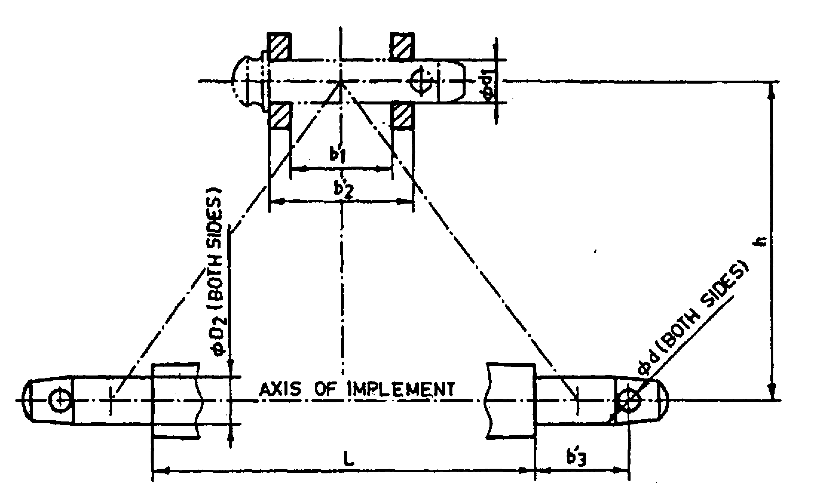
Implement Hitch Attachment

2.6 | Clutch assembly:
 | a) | Constructional details | :
2.6.1 | Upper hitch point:
 | a) | Material | :
 | b) | Size (mm) | :
 | c) | No. of holes on upper hitch point | :
 | d) | Size of hole for fixing upper hitch point (mm) | :
 | e) | Size of hole for fixing j-hook | :
 | f) | Size of hole for fixing lever | :
 | g) | Method of fixing | :
2.6.2 | J-hook:
 | a) | Material | :
 | b) | Size (mm) | :
 | c) | Dia. of hole for fixing j-hook (mm) | :
 | d) | Size of j-hook pin (mm) | :
 | e) | Method of fixing | :
2.6.3 | Lever:
 | a) | Material | :
 | b) | Size (mm) | :
 | c) | Size of hole for fixing with upper hitch | :
 | d) | Method of fixing | : | .
2.6.4 | Adjusting grip:
 | a) | Material | :
 | b) | Method of fixing: | :
3 | Overall dimensions (mm) :
 | a) | Length | :
 | b) | Width | :
 | c) | Height | :
4 | Total mass (kg) |  | :
5 | Color of implement |  | :

Place:
Date:
Signature : _________________________

Name : _________________________

Designation: ________________________

