 | Testing and Training Center of Farm Machinery  Department of Farm Machinery and Power  College of Agricultural Engineering and Technology  Junagadh Agricultural University  JUNAGADH – 362 001 (GUJARAT) | 
P | Phone : (0285) 2672080-90, Ext. 390 & 484; Fax : (0285) 2671018

SPECIFICATION SHEET OF TRACTOR OPERATED ROTARY HARROW

1.0 | General | :
a) | Name | :
b) | Type | :
c) | Make | :
d) | Serial Number | :
e) | Model | :
f) | Year of manufacture | :
g) | Name and address of manufacture | :
h) | Source of power | :
i) | Recommended power of tractor, if tractor operated | :
j) | Selling price in India | :

2.1 | Gang frame:
 | a) | Type and material | :
 | b) | Size of MS pipe (mm) | :
 | c) | Method of fixing | :
2.2 | Weight box::
2.3 | Side support/plate:
 | a) | Number and material
 | b) | Thickness (mm)
 | c) | Size (mm)
 | d) | Method of fixing
 | e) | No. of bearing
2.4 | Scraper assembly:
 | a) | Type and material | :
 | b) | Number | :
 | c) | Size of scrapper (mm) | :
 | d) | Location | :
 | e) | Adjustment | :
2.5 | Gang shaft:
 | a) | Type and material | :
 | b) | Length of shaft (mm) | :
 | c) | Dia. of shaft (mm) | :
 | d) | Length of threaded portion (mm) | :
 | e) | Dia. of threaded portion (mm) | :
2.6 | Disc gang:
 | a) | Number | :
 | b) | No. & type of disc in each gang | :
 | c) | Bearings | :
 | d) | Method of mounting of each disc | :
 | e) | Method of changing the gang angle
 | f) | Method of fixing one gang frame to another | :
2.7 | Gang angle:
 | a) | Angle made between axis of the gang and the line perpendicular to the direction of motion (deg.) | :
2.8 | Spool:
 | a) | Type and no. of spools | :
 | b) | Length (mm) | :
 | c) | Diameter (mm) | :
 | d) | Material | :
 | e) | Dia. of spool with collar
 |  | Big end | :
 |  | Small end | :
 |  | Middle of spool | :
 | f) | Method of mounting | :
 | g) | Type of key | :
 | h) | Size of key (mm) | :
2.9 | Bumper:
 | a) | Type | :
 | b) | Size (mm)
 |  | Diameter | :
 |  | Thickness | :
2.10 | Furrow wheel / Land wheel:
 | a) | Number and material
 | b) | Size (mm)
 | c) | Method of fixing
2.11 | Disc (Refer Fig. 1):
 | a) | Type and no.
 | b) | Method of fixing
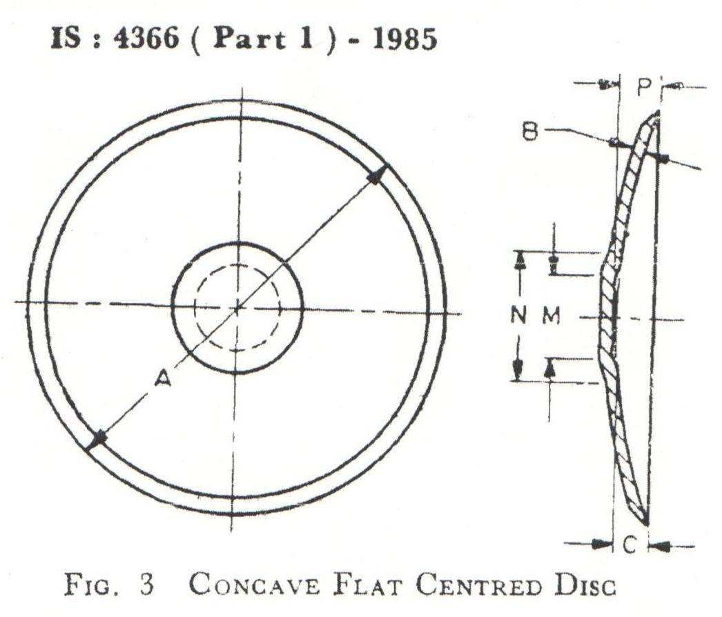
Fig. 1
Sr. | Specification | Size
1 | Nominal size A
2 | Thickness B
3 | Concavity C
4 | M
5 | N
6 | P
7 | Diameter of central hole
8 | Pitch circle diameter
9 | Number of holes
10 | Bevel angle
11 | Marking on disc
 | - Manufacturer’s name or recognized trade-mark if any
 | - Batch / code no.

2.12 | Type of hitch and its details :
 | a) | Type and material | :
 | b) | Shape | :
Specification of Hitch Pyramid As per IS: 4468-1997 (Part-I)

Sr. | Dimension  (Refer Fig.2) | Description | Measurement
Upper Hitch attachments
1 | d₁ | Diameter of hitch pin hole
2 | b’₁ | Width between inner faces of yoke
3 | b’₂ | Width between outer faces of yoke
Lower hitch points
4 | D₂ | Dia. of hitch pin
5 | b’₃ | Linch pin hole distance
6 | l | Lower hitch point span
Other dimensions
 | Diameter of linch pin hole
7 | d | For upper hitch pin
8 |  | For lower hitch pin
9 | h | Mast height

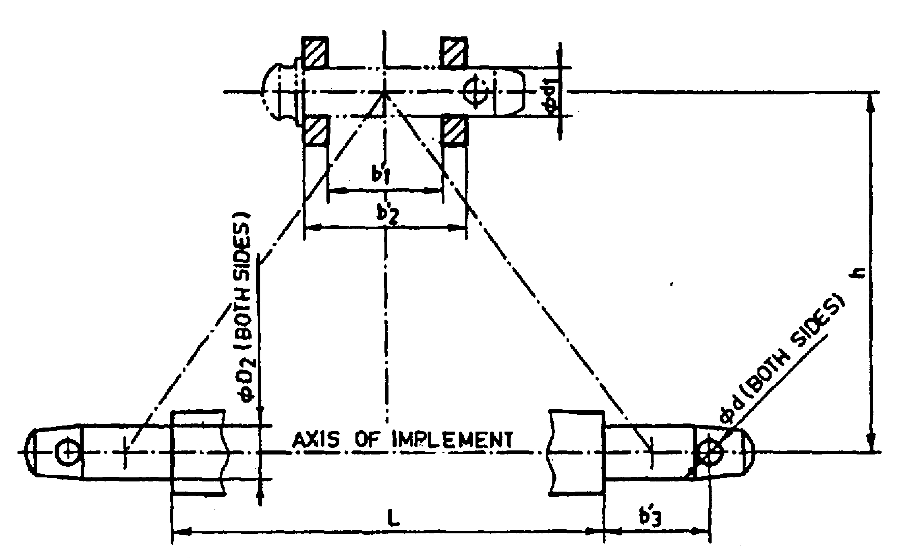
Fig. 2 : Implement Hitch Attachment

2.13 | Power transmission system:
 | a) |  |  | Method of transmission | :
2.13.1 |  | Spline end of rotavator input shaft: |  |  |  |  | Ref. Fig.3
Dimension of Implement Power Input Shaft As per IS: 4931-2006

Sr. |  |  | Specification/ Notations  (Refer Fig.3) |  |  |  |  | Measurement
1 |  |  | PTO Type
2 |  |  | Nominal speed (rpm)
3 |  |  | Nominal dia.(mm)
4 |  |  | Number and type of splines
Dimensions (mm)
5 |  |  | D Φ
6 |  |  | d Φ
7 |  |  | B Φ
8 |  |  | A Φ
9 |  |  | W
10 |  |  | a
11 |  |  | b
12 |  |  | c
13 |  |  | x
14 |  |  | B
15 |  |  | h

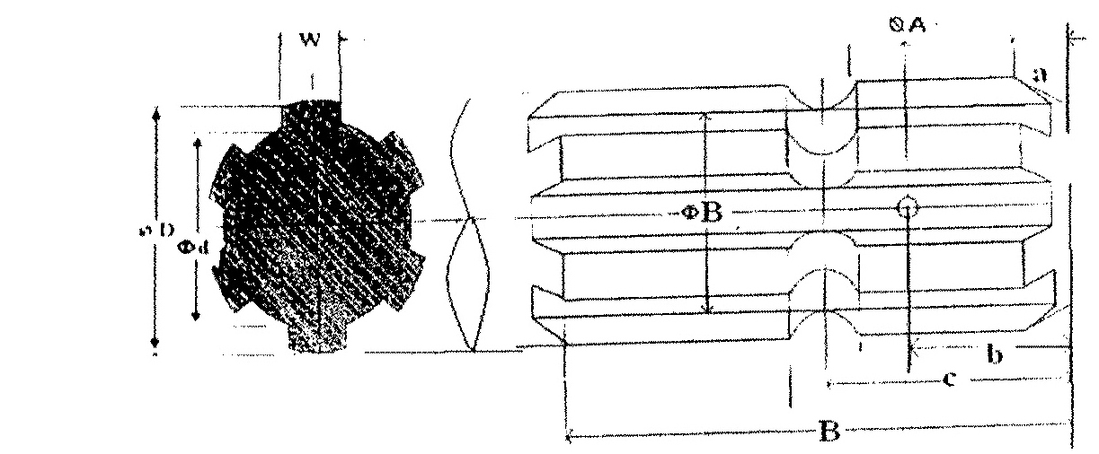

Fig. 3 Dimension of Implement Power Input Shaft

2.13.2 | Gear box assembly (primary reduction):
 | a) | Type | :
 | b) | No. of teeth on pinion
 | c) | No. of teeth on bevel gear | :
 | d) | Reduction ratio at gear box | :
 | e) | Oil capacity (L) | :
 | f) | Oil change period | :
 | g) | Recommended grade of oil
 | h) | Length of power transmission
 | i) | Shaft (mm) (from gear box to secondary reduction unit)
 |  | Dia of shaft (mm)
 | j) | Provision of breather
 | k) | No. of bearing
2.13.3 | Gear box assembly (secondary reduction):
 | a) | Type
 | b) | No. of teeth on drive gear
 | c) | No. of teeth on driven gear
 | d) | Reduction ratio
 | e) | No. of teeth on idler gear
 | f) | Oil capacity (L)
 | g) | Oil change period (hrs.)
 | h) | No. of bearing
2.13.4 | Propeller shaft:
 | a) | Type and material
 | b) | Length of shaft (mm)
 |  | Minimum
 |  | Maximum
 | c) | Mass of shaft (kg)
 | d) | Provision for locking

Propeller Shaft Insert Dimensions As per IS: 4931-2006

Sr. | Notations  (Refer Fig.4)
1 | D Φ
2 | d Φ
3 | W
4 | B
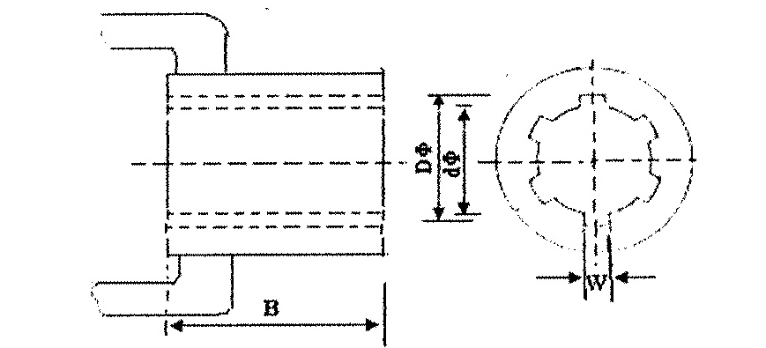
Fig. 4 : Propeller Shaft Insert Dimensions

2.13.5 | Safety clutch/device:
 | Size of bolt(mm) : |  | :
 | a) | Length | :
 | b) | Dia. | :
 | c) | Pitch | :

2.14 | Arrangement of transport | :

3 | Overall dimensions (mm) :
 | a) | Length | :
 | b) | Width | :
 | c) | Height | :
 | d) | Mass, (kg) | :
4 | Color of implement |  | :
5 | Material used

Sr. | Name of components | Material
1 | Frame
2 | Gang axle
3 | Spool
4 | Scraper
5 | Gang angling mechanism
6 | Transport wheel
7 | Loading platform , if provided
8 | Draw bar /hitch
9 | Gang bearing
10 | Hitch pin
11 | Discs
Place:
Date:
Signature : _________________________

Name : _________________________

Designation: ________________________

