 | Testing and Training Center of Farm Machinery  Department of Farm Machinery and Power  College of Agricultural Engineering and Technology  Junagadh Agricultural University  JUNAGADH – 362 001 (GUJARAT) | 
P | Phone : (0285) 2672080-90, Ext. 390 & 484; Fax : (0285) 2671018

SPECIFICATION SHEET OF TRACTOR OPERATED DISC PLOUGH
1.0 | General |  | :
 | Name of machine |  | :
 | Name and address of manufacturer |  | :
 | Name and address of applicant |  | :
 | Selling price in India |  | :
2.1 | Frame:
 | a) | Type and material | :
 | b) | Size of angle section, mm | :
 |  | Left gang
2.2 | Disc flange holder:
 | a) | Type and material | :
 | b) | Size of angle section, mm | :
2.3 | Scraper assembly:
 | a) | Type and material | :
 | b) | Number | :
 | c) | Size of scrapper (mm) | :
 | d) | Location | :
 | e) | Method of fixing | :
 | f) | Adjustment | :
2.4 | Adjustment lever:
 | a) | Type and material | :
 | b) | Length of shaft (mm) | :
 | c) | Dia. of shaft (mm) | :
 | d) | Length of threaded portion (mm) | :
 | e) | Dia. of threaded portion (mm) | :
 | f) | Method of fixing
 | g) | Adjustment
2.5 | Furrow wheel:
 | a) | Number | :
 | b) | Type and material | :
 | c) | Size | :
 | d) | Method of fixing | :
 | e) | Adjustment
.2.6 | Land wheel:
 | a) | Number | :
 | b) | Type and material | :
 | c) | Size | :
 | d) | Method of fixing | :
 | e) | Adjustment
2.7 | Loading platform:
 | a) | Type and material | :
 | b) | Size | :
 | c) | Method of fixing | :
 | d) | Adjustment | :
2.8 | Loading mass:
 | a) | Type and material | :
 | b) | Size | :
 | c) | Method of fixing | :
 | d) | Adjustment | :
2.9 | Concave disc:

Sr. | Specification | Size
1 | Type
2 | Make
3 | Material
4 | Dia. of disc (mm)
5 | Concavity (mm)
6 | Bevel angle
7 | Width of bevel edge (mm)
8 | Thickness of disc (mm)
9 | Thickness of bevel edge (mm)
10 | Type of centre hole
11 | Size of center hole (mm)
12 | Size of key hole (mm)
13 | Method of fixing

2.10 | Type of hitch and its details :
 | a) | Type and material | :
 | b) | Shape | :
Specification of Hitch Pyramid As per IS: 4468-1997 (Part-I)

Sr. | Dimension  (Refer Fig.1) | Description | Measurement
Upper Hitch attachments
1 | d₁ | Diameter of hitch pin hole
2 | b’₁ | Width between inner faces of yoke
3 | b’₂ | Width between outer faces of yoke
Lower hitch points
4 | D₂ | Dia. of hitch pin
5 | b’₃ | Linch pin hole distance
6 | l | Lower hitch point span
Other dimensions
 | Diameter of linch pin hole
7 | d | For upper hitch pin
8 |  | For lower hitch pin
9 | h | Mast height

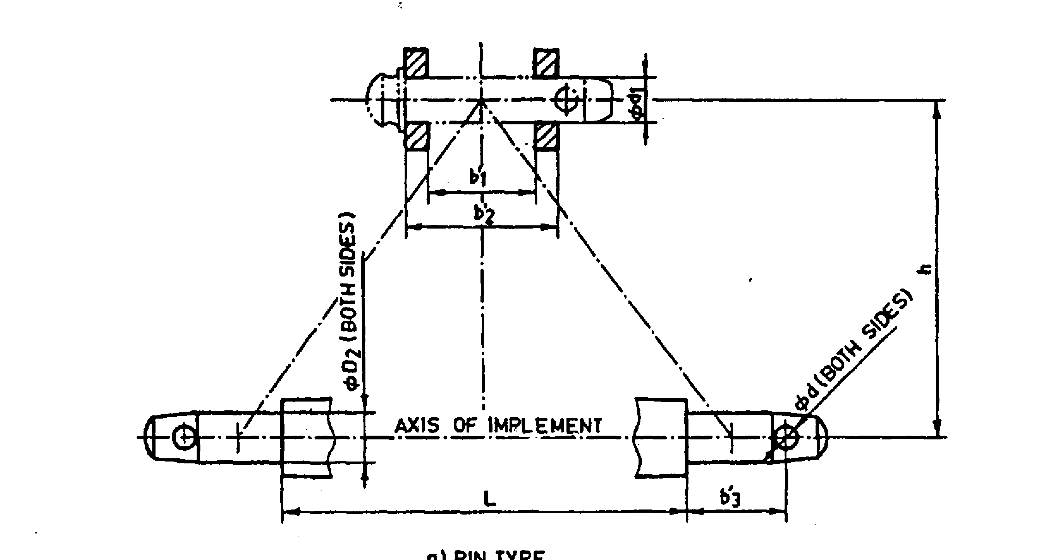
Implement Hitch Attachment

2.11 | Arrangement of transport |  |  | :
3 |  | Overall dimensions (mm) :
 |  | a) | Length | :
 |  | b) | Width | :
 |  | c) | Height | :
 |  | d) | Mass, (kg) | :
4 |  | Color of implement |  | :
5 |  | Material used

Sr. | Name of components | Material
1 | Frame
2 | Disc flange holder
3 | Scraper
4 | Adjustment lever
5 | Furrow wheel
6 | Land wheel
7 | Loading platform | --
8 | Cross bar /hitch
9 | Loading mass
10 | Hitch pin

Place:
Date:
Signature : _________________________

Name : _________________________

Designation: ________________________

