 | Testing and Training Center of Farm Machinery  Department of Farm Machinery and Power  College of Agricultural Engineering and Technology  Junagadh Agricultural University  JUNAGADH – 362 001 (GUJARAT) | 
P | Phone : (0285) 2672080-90, Ext. 390 & 484; Fax : (0285) 2671018

SPECIFICATION SHEET OF TRACTOR OPERATED FERTILIZER BROADCASTER

1.0 | General | :
1.0 | Name | :
1.0 | Type | :
1.0 | Make | :
1.0 | Serial Number | :
1.0 | Model
1.0 | Year of manufacture
1.0 | Name and address of manufacture
1.0 | Source of power
1.0 | Recommended power of tractor, if tractor operated
1.0 | Selling price in India

2.1 |  | Main frame / Chassis:
 |  | a) |  |  | Type |  |  | :
 |  | b) |  |  | Size of box section (mm) |  |  | :
 |  | c) |  |  | Size of supporting flat (mm)
 |  | d) |  |  | Type of mounting of box section
2.2 |  | Hopper:
 |  | a) |  |  | Shape |  |  | :
 |  | b) |  |  | Inner diameter of hopper (mm) |  |  | :
 |  | c) |  |  | Hopper capacity (lit) |  |  | :
 |  | d) |  |  | Material and thickness (mm) |  |  | :
 |  | e) |  |  | Internal height at side (mm) |  |  | :
 |  | f) |  |  | Internal height at centre (mm) |  |  | :
 |  | g) |  |  | Size of hole at bottom (mm) |  |  | :
 |  | h) |  |  | Bottom slope (degree) |  |  | :
 |  | i) |  |  | Ratio between diameter and height of hopper |  |  | :
 |  | k) |  |  | Method of fixing the hopper with main frame |  |  | :
2.3 |  | Agitator:
 |  | a) |  | Shape |  |  |  | :
 |  | b) |  | Location |  |  |  | :
 |  | c) |  | Material and thickness (mm) |  |  |  | :
 |  | d) |  | Size of agitator (mm) |  |  |  | :
 |  | e) |  | Vertical clearance of agitator above the aperture (mm) |  |  |  | :
 |  | f) |  | Arrangement for fixing of agitator to the centre shaft |  |  |  | :
2.4 |  | Feed control mechanism:
2.4.1 |  | Funnel
 |  | a) |  |  | Shape |  |  | :
 |  | b) |  |  | Material and thickness (mm) |  |  | :
 |  | c) |  |  | Size of hole (mm) |  |  | :
 |  | d) |  |  | Outer dia. of cone (mm) |  |  | :
 |  | e) |  |  | Cone slope (degree) |  |  | :
 |  | f) |  |  | Arrangement for fixing of feed control of hopper |  |  | :
2.4.2 |  | Feed control lever
 |  | a) |  |  | Type |  |  | :
 |  | b) |  |  | Material and thickness (mm) |  |  | :
 |  | c) |  |  | Size of lever (mm) |  |  | :
 |  | d) |  |  | Arrangement for fixing of lever to feed control |  |  | :
2.4.3 |  | Lever grip
 |  | a) |  |  | Shape |  |  | :
 |  | b) |  |  | Material |  |  | :
 |  | c) |  |  | Size of plastic grip (mm) |  |  | :
 |  | d) |  |  | Method of fixing the grip to hopper |  |  | :
2.4.4 |  | Locking device (feed control)
 |  | a) |  |  | Shape |  |  | :
 |  | b) |  |  | Material |  |  | :
 |  | c) |  |  | Size of grip (mm) |  |  | :
 |  | d) |  |  | Arrangement for fixing of screw to hopper |  |  | :
2.4.5 |  | Guide strip
 |  | a) |  |  | Shape |  |  | :
 |  | b) |  |  | Material |  |  | :
 |  | c) |  |  | Size of strip (mm) |  |  | :
 |  | d) |  |  | Arrangement for holding the strip on hopper |  |  | :
2.5 |  | Collar for spreading disc:
 |  | a) |  |  | Shape |  |  | :
 |  | b) |  |  | Material |  |  | :
 |  | c) |  |  | Dia. of collar |  |  | :
 |  | d) |  |  | Length of collar (mm) |  |  | :
 |  | e) |  |  | Thickness of collar (mm) |  |  | :
 |  | f) |  |  | Arrangement for fixing of collar to centre shaft and spreading disc |  |  | :
2.6 |  | Spreading disc:
 |  | a) |  |  | Shape |  |  | :
 |  | b) |  |  | Material |  |  | :
 |  | c) |  |  | Dia. of disc (mm) |  |  | :
 |  | d) |  |  | Width of outer edge (mm) |  |  | :
 |  | e) |  |  | Vertical clearance below the hopper bottom (mm) |  |  | :
 |  | f) |  |  | Thickness of disc (mm) |  |  | :
 |  | g) |  |  | Direction of rotation |  |  | :
 |  | h) |  |  | Arrangement for fixing of disc to collar |  |  | :
2.7 |  | Fins:
 |  | a) |  |  | Shape |  |  | :
 |  | b) |  |  | Material |  |  | :
 |  | c) |  |  | No. of fins |  |  | :
 |  | d) |  |  | Size of fins (mm) |  |  | :
 |  | e) |  |  | Spacing between two fins at outer edge (mm) |  |  | :
 |  | f) |  |  | Arrangement for fitting of fins to spreading disc |  |  | :
2.8 |  | Drive mechanism: |  |  |  |  |  | :
2.8.1 |  | Centre shaft
 |  | a) |  |  | Shape |  |  | :
 |  | b) |  |  | Material |  |  | :
 |  | c) |  |  | Dia. (mm) |  |  | :
 |  | d) |  |  | Length (mm) |  |  | :
 |  | e) |  |  | Arrangement for fixing of centre shaft to main frame |  |  | :
2.8.2 |  | Driven gear
 |  | a) |  |  | Type |  |  | :
 |  | b) |  |  | Material |  |  | :
 |  | c) |  |  | No. of teeth |  |  | :
 |  | d) |  |  | Method of firing the gear with shaft |  |  | :
2.8.3 |  | Gear shaft
 |  | a) |  |  | Type |  |  | :
 |  | b) |  |  | Material |  |  | :
 |  | c) |  |  | Dia. (mm) |  |  | :
 |  | d) |  |  | Length (mm) |  |  | :
 |  | e) |  |  | Arrangement for fixing the gear shaft to main frame |  |  | :
2.8.4 |  | Intermediate gear
 |  | a) |  |  | Type |  |  | :
 |  | b) |  |  | Material |  |  | :
 |  | c) |  |  | No. of teeth |  |  | :
 |  | d) |  |  | Arrangement for fixing the gears to gear shaft |  |  | :
2.8.5 |  | Crank rod
 |  | a) |  |  | Shape |  |  | :
 |  | b) |  |  | Material |  |  | :
 |  | c) |  |  | Dia. (mm) |  |  | :
 |  | d) |  |  | Length (mm) |  |  | :
 |  | e) |  |  | Arrangement for fixing of crank rod |  |  | :
2.8.6 |  | Drive gear on crank rod
 |  | a) |  |  | Type |  |  | :
 |  | b) |  |  | Material |  |  | :
 |  | c) |  |  | No. of teeth |  |  | :
 |  | d) |  |  | Gear ratio between drive and intermediate bevel gear |  |  | :
 |  | d) |  |  | Arrangement for fixing of drive gear on crank shaft |  |  | :
2.8.7 |  | Crank bolt
 |  | a) |  |  | Type |  |  | :
 |  | b) |  |  | Material |  |  | :
 |  | c) |  |  | Size of crank bolt (mm) |  |  | :
 |  | d) |  |  | Pitch (mm) |  |  | :
 |  | e) |  |  | Size of threaded locking bolt (mm) |  |  | :
 |  | f) |  |  | Arrangement for fixing crank bolt |  |  | :
2.8.8 |  | Crank
 |  | a) |  |  | Shape |  |  | :
 |  | b) |  |  | Material |  |  | :
 |  | c) |  |  | Max. length of crank (mm) |  |  | :
 |  | d) |  |  | Dia. of crank rod (mm) |  |  | :
 |  | e) |  |  | Length of crank between the centre of crank shaft to centre of handle (mm) |  |  | :
 |  | f) |  |  | Arrangement for fixing crank bolt and handle |  |  | :
2.9 |  |  | Type of hitch and its details :
 |  |  | a) |  |  | Type and material |  | :
 |  |  | b) |  |  | Shape |  | :
Specification of Hitch Pyramid

Sr. | Dimension  (Refer Fig.1) |  |  |  |  |  | Description |  |  | Measurement
Upper Hitch attachments
1 | d₁ |  |  |  |  |  | Diameter of hitch pin hole
2 | b’₁ |  |  |  |  |  | Width between inner faces of yoke
3 | b’₂ |  |  |  |  |  | Width between outer faces of yoke
Lower hitch points
4 | D₂ |  |  |  |  |  | Dia. of hitch pin
5 | b’₃ |  |  |  |  |  | Linch pin hole distance
6 | l |  |  |  |  |  | Lower hitch point span
Other dimensions
 | Diameter of linch pin hole
7 | d |  |  |  |  |  | For upper hitch pin
8 |  |  |  |  |  |  | For lower hitch pin
9 | h |  |  |  |  |  | Mast height

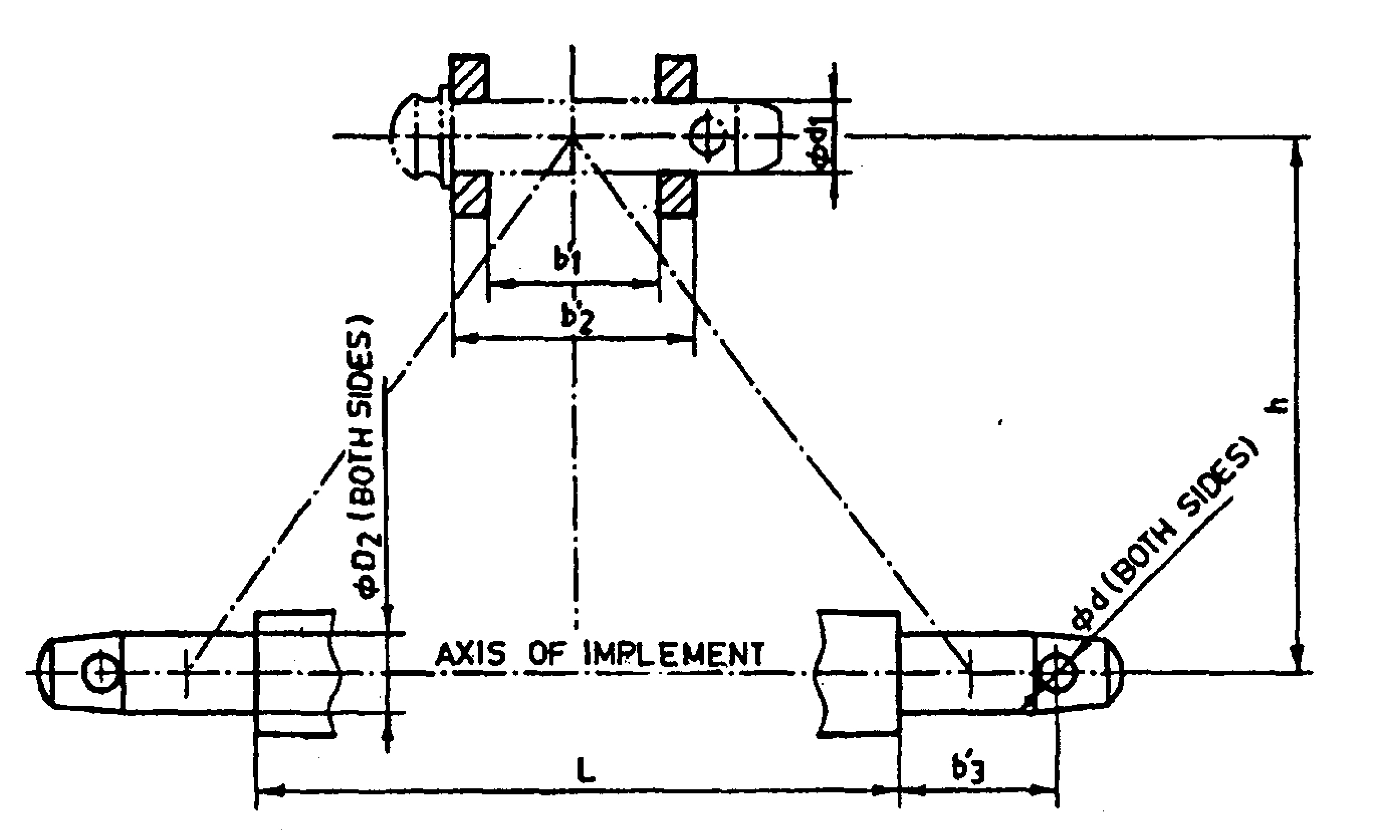
Fig. 1 : Implement Hitch Attachment

2.10 | Power transmission system:
2.10 | a) |  |  |  | Method of transmission | :
2.10.1 |  | Spline end of input shaft: |  |  |  |  |  | Ref. Fig.2
 |  | a) |  | PTO Type and material |  | :
 |  | b) |  | Nominal speed (rpm) |  | :
 |  | c) |  | Nominal dia.(mm) |  | :
 |  | d) |  | Number and type of splines |  | :
Dimension of Implement Power Input Shaft
Sr. |  |  | Specification/ Notations  (Refer Fig.2) |  |  |  |  |  | Measurement
1 |  |  | PTO Type
2 |  |  | Nominal speed (rpm)
3 |  |  | Nominal dia.(mm)
4 |  |  | Number and type of splines
Dimensions (mm)
5 |  |  | D Φ
6 |  |  | d Φ
7 |  |  | B Φ
8 |  |  | A Φ
9 |  |  | W
10 |  |  | a
11 |  |  | b
12 |  |  | c
13 |  |  | x
14 |  |  | B
15 |  |  | h

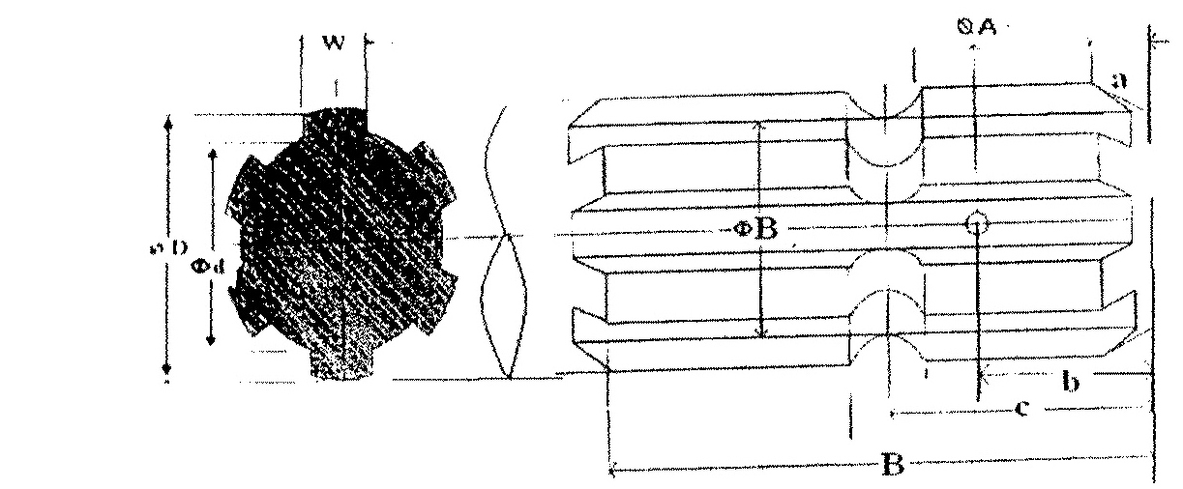

Fig. 2 Dimension of Implement Power Input Shaft

2.10.2 | Gear box assembly (primary reduction):
2.10.2 | a) | Type | :
2.10.2 | b) | No. of teeth on pinion
2.10.2 | c) | No. of teeth on bevel gear | :
2.10.2 | d) | Reduction ratio at gear box | :
2.10.2 | e) | Oil capacity (L) | :
2.10.2 | f) | Oil change period | :
2.10.2 | g) | Recommended grade of oil
2.10.2 | h) | Length of power transmission
2.10.2 | i) | Shaft (mm) (from gear box to secondary reduction unit)
2.10.2 |  | Dia of shaft (mm)
2.10.2 | j) | Provision of breather
2.10.2 | k) | No. of bearing
2.10.3 | Gear box assembly (secondary reduction):
2.10.3 | a) | Type
2.10.3 | b) | No. of teeth on drive gear
2.10.3 | c) | No. of teeth on driven gear
2.10.3 | d) | Reduction ratio
2.10.3 | e) | No. of teeth on idler gear
2.10.3 | f) | Oil capacity (L)
2.10.3 | g) | Oil change period (hrs.)
2.10.3 | h) | No. of bearing
2.10.4 | Propeller shaft:
2.10.4 | a) | Type and material
2.10.4 | b) | Length of shaft (mm)
2.10.4 |  | Minimum
2.10.4 |  | Maximum
2.10.4 | c) | Mass of shaft (kg)
2.10.4 | d) | Provision for locking

Propeller Shaft Insert Dimensions

Sr. | Notations  (Refer Fig.3)
1 | D Φ
2 | d Φ
3 | W
4 | B
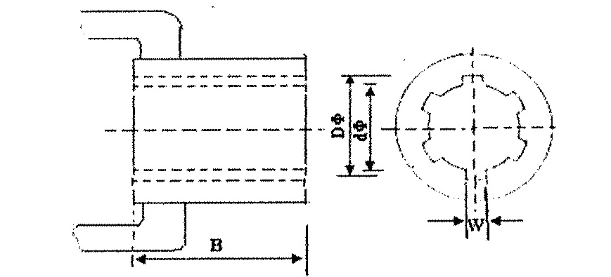
Fig. 3 : Propeller Shaft Insert Dimensions

2.10.5 | Safety clutch/device:
2.10.5 | Size of bolt(mm) : |  | :
2.10.5 | a) | Length | :
2.10.5 | b) | Dia. | :
2.10.5 | c) | Pitch | :

3.0 | Overall Dimensions (mm)
3.0 | a) | Length | :
3.0 | b) | Width | :
3.0 | c) | Height | :
3.0 | d) | Mass, (kg) | :
4.0 | Color of implement

5.0 | Details of Material of Construction :
Sr. | Name of part | Material | Section or size in mm
1 | 2 | 3 | 4
1 | Frame
2 | Hitch
3 | Hitch pin
4 | Hopper
5 | Lid
6 | Spreading disc
7 | Handle
8 | Gears
9 | Agitators
10 | Gear shaft
11 | Centre shaft
12 | Crank shaft
13 | Feed control mechanism
14 | Strap

Place:
Date:
Signature : _________________________

Name : _________________________

Designation: ________________________

