 | Testing and Training Center of Farm Machinery  Department of Farm Machinery and Power  College of Agricultural Engineering and Technology  Junagadh Agricultural University  JUNAGADH – 362 001 (GUJARAT) | 
P | Phone : (0285) 2672080-90, Ext. 390 & 484; Fax : (0285) 2671018

SPECIFICATION SHEET OF POWER THRESHER FOR GROUNDNUT

1 | Name of Machine
2 | Name and address of Manufacturer
3 | Name and address of applicant
4 | Selling price in India

4 SPECIFICATIONS
4.1 | General:
a) | Name | : | Power Thresher for Groundnut
b) | Type | :
c) | Make | :
d) | Serial Number | :
e) | Model | :
f) | Size of thresher (mm) | :
g) | Recommended source of power by applicant | :
h) | Design suitability as per applicant | :
 | -Main crop recommended | :
 | -Other crops recommended | :
 | -Thresher evaluated for | :
i) | Year of manufacture | :

4.2 | Constructional Details
4.2.1 | Frame/Stand:
 | a) | Constructional details | : | Four legged made of MS angle iron. The legs are joined with each other with other supporting angle iron. Two legs are provided with axle for transport wheels.
 | b) | Type | : | 28x28x3
 | c) | Size (mm) | : | 770
 | d) | Material | :
 | e) | Size of rectangular box (mm) | :
4.2.2 | Power unit
 | a) | Provision | :
 | b) | Type of prime mover, recommended by the applicant | :
 | c) | Recommended power, (kW or hp) | :
 | d) | Type of drive | :
4.2.3 | Main drive
 | a) | Type | :
 | b) | Size of belt | :
 | c) | Size of pulley (mm) | :
 | d) | Diameter of main shaft (mm) | :
4.2.4 | Threshing cylinder
4.2.4.1 | Cylinder
 | a) | Type | :
 | b) | Constructional feature | :
 | c) | Diameter (mm) | :
 | d) | Width (mm) | :
 | e) | Recommended speed (rpm) | :
 | f) | Number and type of bearings | :
 | g) | Number and size of beaters /projections/bars (mm) | :
 | h) | Spacing between beaters (mm) | :
 | i) | Direction of rotation | :
4.2.4.2 | Concave
 | a) | Type | :
 | b) | Diameter or width (mm) | :
 | c) | Length (mm) | :
 | d) | Concave clearance range (mm) | :
 | e) | Recommended concave clearance (mm) | :
 | f) | Method of clearance adjustment | :
 | g) | Constructional feature | :
 | h) | Method of fixing | :
4.2.5 | Sieve
 | a) | Type | :
 | b) | Number | :
 | c) | Total length and width (mm) | :
 | d) | Effective length and width (mm) | :
 | e) | Number of holes per cm² | :
 | f) | Size of hole (mm) | :
 | g) | Sieve clearance (mm) | :
 | h) | Screen slope range (º) | :
 |  | Recommended screen slope (º) | :
 | i) | Method of mounting | :
4.2.6 | Shaker
 | a) | Type | :
 | b) | Number of strokes per minute | :
 | c) | Drive | :
 | d) | Number and type of bearings | :
4.2.7 | Blower
 | a) | Number | :
 | b) | Type | :
 | c) | Number of blades | :
 | d) | Size of blades (mm) | :
 | e) | Diameter (mm) | :
 | f) | Recommended speed (rpm) | :
 | g) | Recommended air displacement (m³/h) | :
 | h) | Provision for changing air displacement | :
 | i) | Size of inlet opening (mm) | :
 | j) | Size of outlet opening (mm) | :
 | k) | Drive | :
 | l) | Number and type of bearings | :
4.2.8 | Elevator
 | a) | Type | :
 | b) | Constructional details | :
 | c) | Capacity | :
 | d) | Drive | :
 | e) | Grain spout size (mm) | :
 | f) | Height above ground level (mm) | :
 | g) | Number and type of bearings | :
4.2.9 | Crop feeding
 | a) | Type | :
 | b) | Method of feeding | :
 | c) | Size of hopper (mm) | :
 | d) | Height and location of hopper (mm) | :
 | e) | Recommended maximum feed rate (kg/h) | :
The dimensions of the hopper and star wheels when in conjunction with Fig. X shall be as given in below Table.
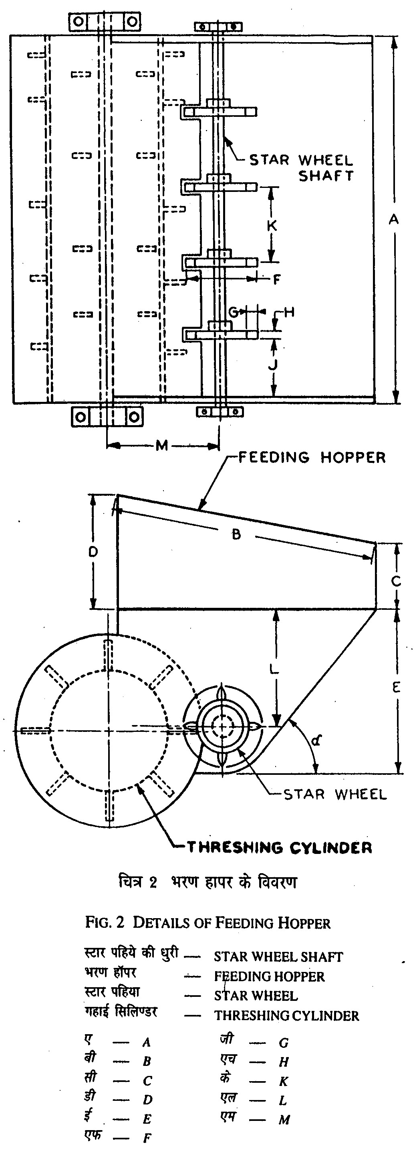
Table: Dimensions hopper and star wheel (mm)

Notations | Size of the prime mover for thresher kW
Notations | 7.5 | 11 | 15 | 18.7 and above
B Min | 900 | 900 | 925 | 950
C Min | 180 | 200 | 220 | 240
D Min | 340 | 370 | 400 | 430
E Min | 75 | 500 | 535 | 565
F | 280 | 280 | 280 | 280
G | 45 | 45 | 45 | 45
H | 20 | 20 | 20 | 20
α+5º | 50 | 50 | 50 | 50
Note: Hopper feeding system is normally used with the threshers of 7.5 kW or more power ratings.

4.2.10 | Transport
 | a) | Type | :
 | b) | Number of wheels | :
 | c) | Size of wheels (mm) | :
 | d) | Wheel bearings | :
 | e) | Type of towing arrangement | :
4.2.11 | Flywheel size
 | a) | Number of flywheels | :
 | b) | Diameter (mm) | :
 | c) | Mass (kg) | :
4.2.12 | Overall dimension
 | a) | Length (mm) | :
 | b) | Width (mm) | :
 | c) | Height (mm) | :
 | d) | Ground clearance (mm) | :
 | e) | Total mass (without prime mover) (kg) | :
 | f) | Colour | :

4.3 | Details of material of construction :
Material of Construction Data Sheet (Annex B, Clause 6.2, IS:11234-2001)

Sr. | Components | Material
1 | Frame
2 | Feeding chute
3 | Threshing unit
4 | Drum
5 | Beater/projection/bar
6 | Concave
7 | Blower
8 | Main shaft
9 | Blower shaft
10 | Flywheel
11 | Sieve
12 | Shaker
13 | Elevator
14 | Transport wheel
15 | Pulleys
16 | Hoppe
17 | Star wheels
18 | Star wheel shaft
19 | Others

4.4 | Adjustments:
Items | Method of adjustment | Range
Items | Method of adjustment | For Groundnut crop | Other crops*
Threshing cylinder speed (rpm) | By changing pulley/setting the engine speed
Concave clearance (mm) | By lowering/raising the concave
Blower speed (rpm) | Changes according to threshing cylinder speed
Shaker pulley speed (rpm) | By changing pulley
Length of stroke (mm) | Fixed
Angle of sieves (º) Top- Middle-Bottom | Fixed
Blower inflow adjustment | Circular shutters are provided on both sides

4.5 | Lubricating points:
Sr. | Location | Number of grease cups | Recommended lubricant | Lubricating schedule
1 | Main shaft bearings
2 | Blower shaft bearings
3 | Shaking mechanism
4 | Straw Walker
 | - At rear
 | - At front

Place:
Date:
Signature : _________________________

Name : _________________________

Designation: ________________________

