 | Testing and Training Center of Farm Machinery  Department of Farm Machinery and Power  College of Agricultural Engineering and Technology  Junagadh Agricultural University  JUNAGADH – 362 001 (GUJARAT) | 
P | Phone : (0285) 2672080-90, Ext. 390 & 484; Fax : (0285) 2671018

SPECIFICATION SHEET OF TRACTOR OPERATED GROUNDNUT DIGGER

1 | Name of machine | :
2 | Name and address of manufacturer | :
3 | Name and address of applicant | :
 | Selling price in India | :

4. SPECIFICATIONS
(Appendix A, Clause 3.2 and 6.1, IS:11235-2006)
4.1 | General:
 | a) |  | Name |  | :
 | b) |  | Type |  | :
 | c) |  | Make |  | :
 | d) |  | Serial Number |  | :
 | e) |  | Model |  | :
 | f) |  | Year of manufacture |  | :
 | g) |  | Recommended source of power as per applicant |  | :
4.2 |  | Constructional Details:
4.2.1 |  | Main frame:
 |  | a) |  | Type and material |  | :
 |  | b) |  | Size (mm) |  | : |  | 1610x1440

4.2.2 | Blade:
 | a) | Type and Material | :
 | b) | Number | :
 | c) | Size (mm) | :
 | d) | Inclination angle | :
 | e) | Clearance from ground (mm) | :
 | f) | Clearance from main frame (mm) | :
 | g) | Method of fixing | :

4.2.3 | Elevator chain conveyor :
 | a) | Material and type | :
 | b) | Size (mm)
 |  | Peripheral length | :
 |  | Width | :
 | c) | Conveyor rack material and size (mm) | :
 | d) | Spacing between racks (mm) | :
 | e) | Number of racks | :
 | f) | Material, nos. and size (mm) of spikes on racks | :
 | g) | Slope of conveyor | :
 | h) | Method of power transmission | :
4.2.4 | Rear support / Depth control wheel:
 | a) | Type | :
 | b) | Number | :
 | c) | Size | :
 | d) | Spacing (mm) | :
 | e) | Hub diameter (mm) | :
4.2.5 | Safety features :
 | a) | PTO guard | :
 | b) | V-belt guard | :
4.2.6 | Type of hitch and its details :
 | a) | Type | :
 | b) | Constructional details | :

Specification of Hitch Pyramid As per IS: 4468-1997 (Part-I)

Sr. | Dimension  (Refer Fig.1) | Description | Measurement
Upper Hitch attachments
1 | d₁ | Diameter of hitch pin hole
2 | b’₁ | Width between inner faces of yoke
3 | b’₂ | Width between outer faces of yoke
Lower hitch points
4 | D₂ | Dia. of hitch pin
5 | b’₃ | Linch pin hole distance
6 | l | Lower hitch point span
Other dimensions
 | Diameter of linch pin hole
7 | d | For upper hitch pin
8 |  | For lower hitch pin
9 | h | Mast height

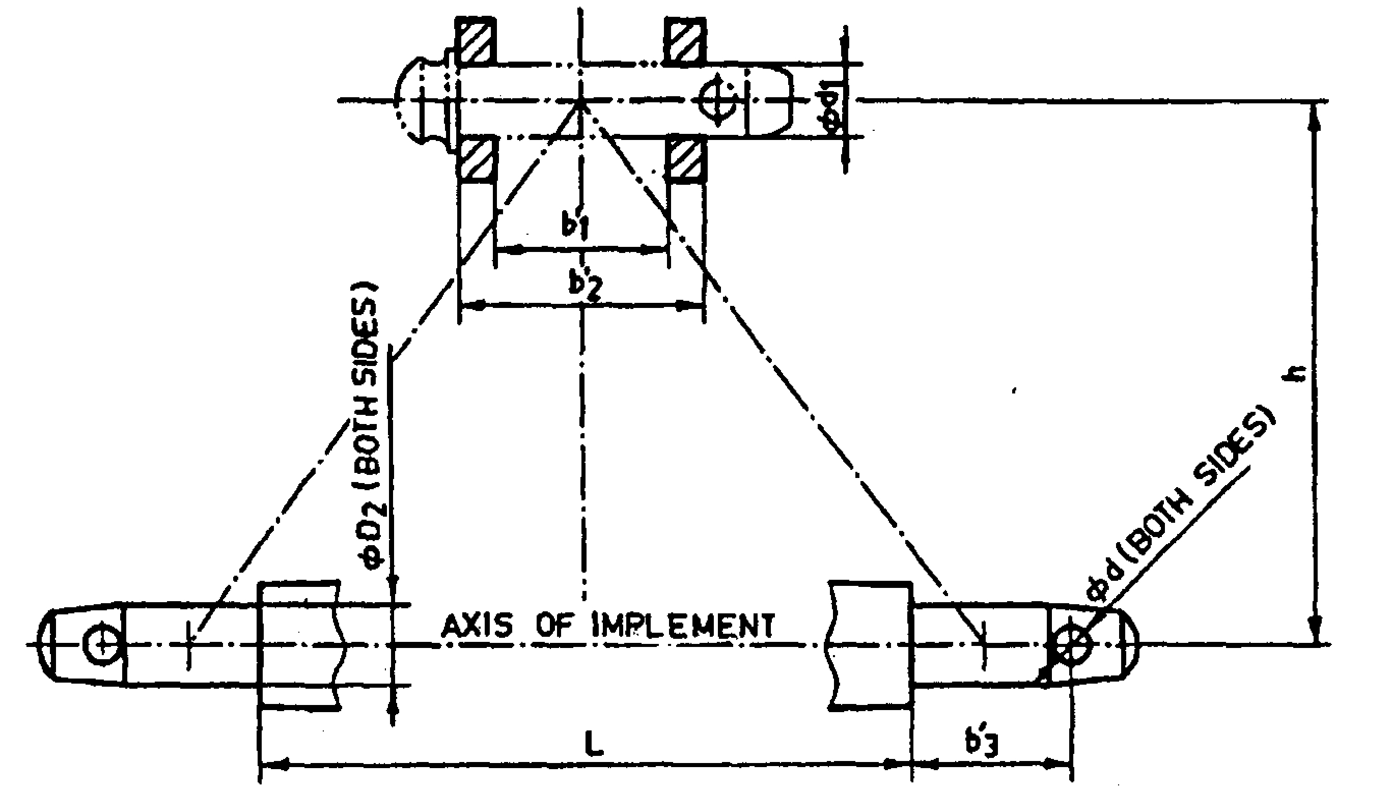
Fig. 3 : Implement Hitch Attachment
4.2.7 |  | Power transmission system:
 |  | a) |  | Method of transmission | :
4.2.7.1 |  |  | Splined end of digger input shaft (Refer Fig. 4):
Sr. | Specification/ Notations  (Refer Fig.2) |  |  |  |  |  | Measurement
1 | PTO Type
2 | Nominal speed (rpm)
3 | Nominal dia.(mm)
4 | Number and type of splines
Dimensions (mm)
5 | D Φ
6 | d Φ
7 | B Φ
8 | A Φ
9 | W
10 | a
11 | b
12 | c
13 | x
14 | B
15 | h
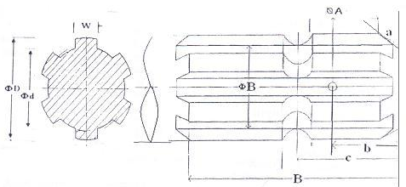
Fig. 4: Dimension of Implement Power Input Shaft
4.2.7.2 |  | Gear box assembly (primary reduction):
 |  | a) |  | Type |  | :
 |  | b) |  | No. of teeth on pinion |  | :
 |  | c) |  | No. of teeth on bevel gear |  | :
 |  | d) |  | Reduction ratio at gear box |  | :
 |  | e) |  | Oil capacity (L) |  | :
 |  | f) |  | Oil change period (hr) |  | :
 |  | g) |  | Recommended grade of oil |  | :
 |  | h) |  | Length of power transmission shaft (mm) (from gear box to front pulley) |  | :
 |  | i) |  | Diameter of shaft (mm) |  | :
 |  | j) |  | Provision of breather |  | :
4.2.7.3 |  | Gear box to conveyor upper pulley (secondary reduction) :
 |  | a) |  | Front pulley diameter (mm) |  | :
 |  | b) |  | Rear pulley diameter (mm) |  | :
 |  | c) |  | V-belt size, number |  | :
 |  | d) |  | Provision of belt tightening |  | :
 |  | e) |  | Dia. of casing of output shaft (mm) |  | :
 |  | f) |  | Dia. of rear drive shaft (mm) |  | :
4.2.7.4 | Propeller shaft (Refer Fig. 5) |  |  |  | :
 | a) |  | Type and material |  | :
 | b) |  | Length of shaft (mm) |  | :
 | c) |  | Mass of shaft (kg) |  | :
 | d) |  | Provision for locking |  | :
Propeller Shaft Insert Dimensions As per IS: 4931-2006

Sr. | Notations  (Refer Fig.3)
1 | D Φ
2 | d Φ
3 | W
4 | B

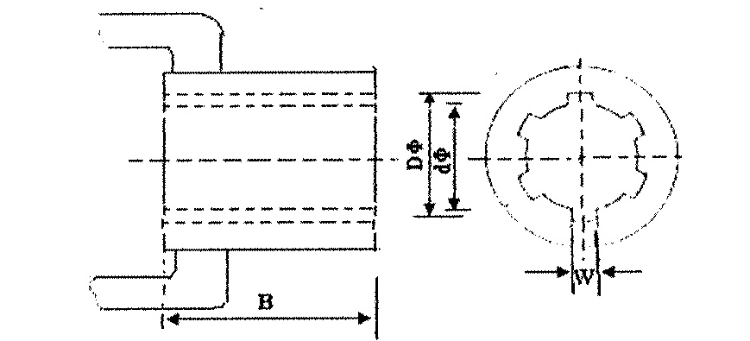
Fig. 5 : Propeller Shaft Insert Dimensions
4.2.8 | Windrowing mechanism:
 | a) | Type and material | :
4.3 | Overall Dimensions (mm):
 | a) | Length | :
 | b) | Width | :
 | c) | Height | :
 | d) | Mass (kg) | :
4.4 | Color of implement |  | :

4.5 | Details of Material of Construction : (Cl. 6.1.1.(b) and 8.2 of IS:13818-1999)
Sr. | Name of part | Material
1 | 2 | 3
1 | Frame | MS tubular pipe
2 | Elevator racks
3 | Blade
4 | Main shaft
5 | Conveyor shaft
6 | Chain Sprocket
7 | Pulley
8 | Rear support/ Depth control wheel

Place:
Date:
Signature : _________________________

Name : _________________________

Designation: ________________________

